|  |  |
| --- | --- |
|  | **FPT ACADEMY INTERNATIONAL**  **FPT – APTECH COMPUTER EDUCATION** |

**Centre Name: ACE-THUDUC-1-FPT.**

**Address: 21 Bis Hau Giang Street, Tan Son Nhat Ward, Ho Chi Minh City.**

**Java Florist**

**Design Document**

|  |  |  |
| --- | --- | --- |
| **Supervisor:** | Mr. Hoang Duc Quang | |
| **Semester:** | 3 | |
| **Batch No:** | T1.2406.E1 | |
| **Group No:** | 1 | |
| **Order:** | **Full name** | **Roll No.** |
| 1. | |  | | --- | | **Trần Trung Anh** | |  | | **Student1571996** |
| 2. | |  | | --- | | **Đặng Quốc Khánh** | |  | | **Student1572003** |
| 3. | |  | | --- | | **Lê Nguyễn Gia Huy** | |  | | **Student1571995** |
| 4. | |  | | --- | | **Thân Thế Lộc** | |  | | **Student1571994** |
| 5. | **Vũ Thị Hoài Thu** | **Student1571993** |

November 2025

Catalog

I. Work Process 3

1. Customer 3

2. Admin 3

3. Partner 4

II. GUI DESIGN 5

1. User interface 5

1.1 Homepage 5

1.2 About Us 6

1.3 Register Page 7

1.4 Login Page 8

1.5 All- 8

1.5 Bouquets Page 9

1.6 Order Page 11

1.7 Check Out Page 12

1.8 PayPal page 13

1.9 Use Dashboard 14

1.10 Your Profile 15

1.11 User Order History 16

2.Partner 17

2.1 Partner Registration 17

2.2 Partner Dashboard 18

2.3 Acount manager 19

2.4 Order Managemnt 20

3. Admin 21

3.1 Login Admin 21

3.2 User Management 22

3.3 User Management (Detail Page) 23

3.4 Bouquet Management 24

3.5 Bouquet Management(Edit page) 25

3.6 Bouquet Management(Add page) 26

3.7 Pending Partner Applications 27

3.8 Order Management 28

## Work Process

### Customer

Customer can use system for:

* Before login:
* View all bouquets
* Search bouquets by ocassion
* Add to cart
* About Us
* Register
* Login
* Forgot password
* View partner registration form
* After login:
* View all bouquets
* Search bouquets by ocassion
* Add to cart
* Order Information Form
* Make payment
* About Us
* View Profile
* Edit personal information
* Change Password
* View My Orders

### Admin

Admin must login first to manage system

* Logout
* User management:
* View user list
* View user information details
* Delete User
* Bouquet management:
* View bouquet list
* Add new bouquet
* Update bouquet
* Delete bouquet
* Partner Orders Management:
* View all orders from partners
* Search order
* View order details
* Coordinate orders for other partner
* Partner Approvals:
* View partner application
* Application review

### Partner

Partner can use system for:

* Before login:
* View all bouquets
* Search bouquets by ocassion
* Add to cart
* About Us
* Register
* Login
* Forgot password
* View partner registration form
* After login:
* View all bouquets
* Search bouquets by ocassion
* View the list of assigned orders
* Update status order
* View analysis report
* View Profile
* Edit personal information

## GUI DESIGN

### User interface

#### Homepage

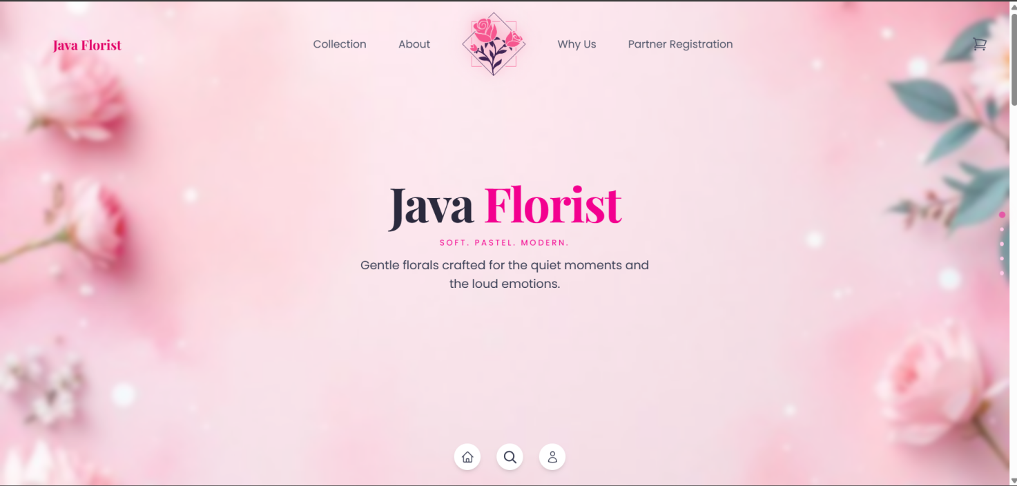

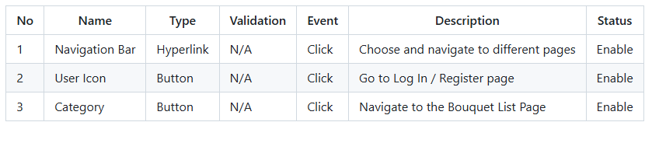

#### About Us

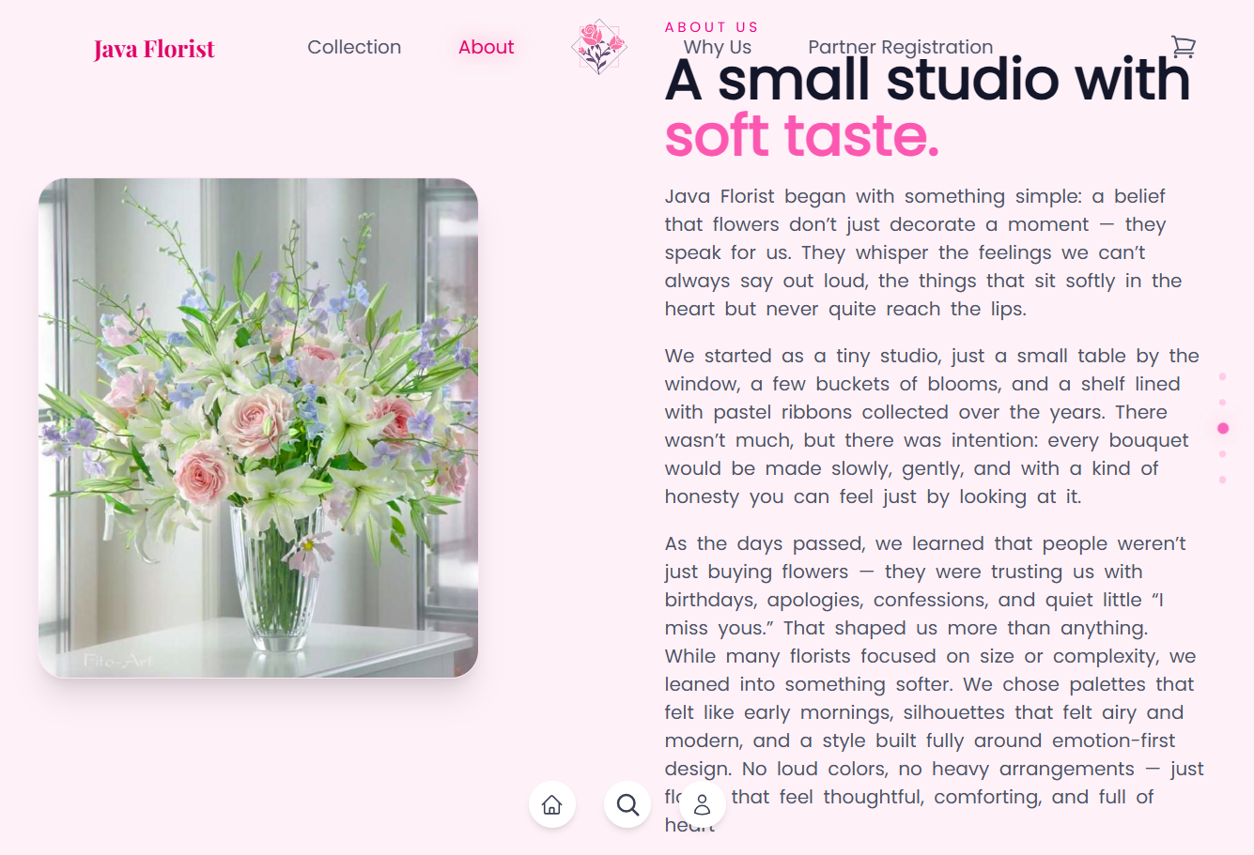

### 

#### 1.3 Register Page

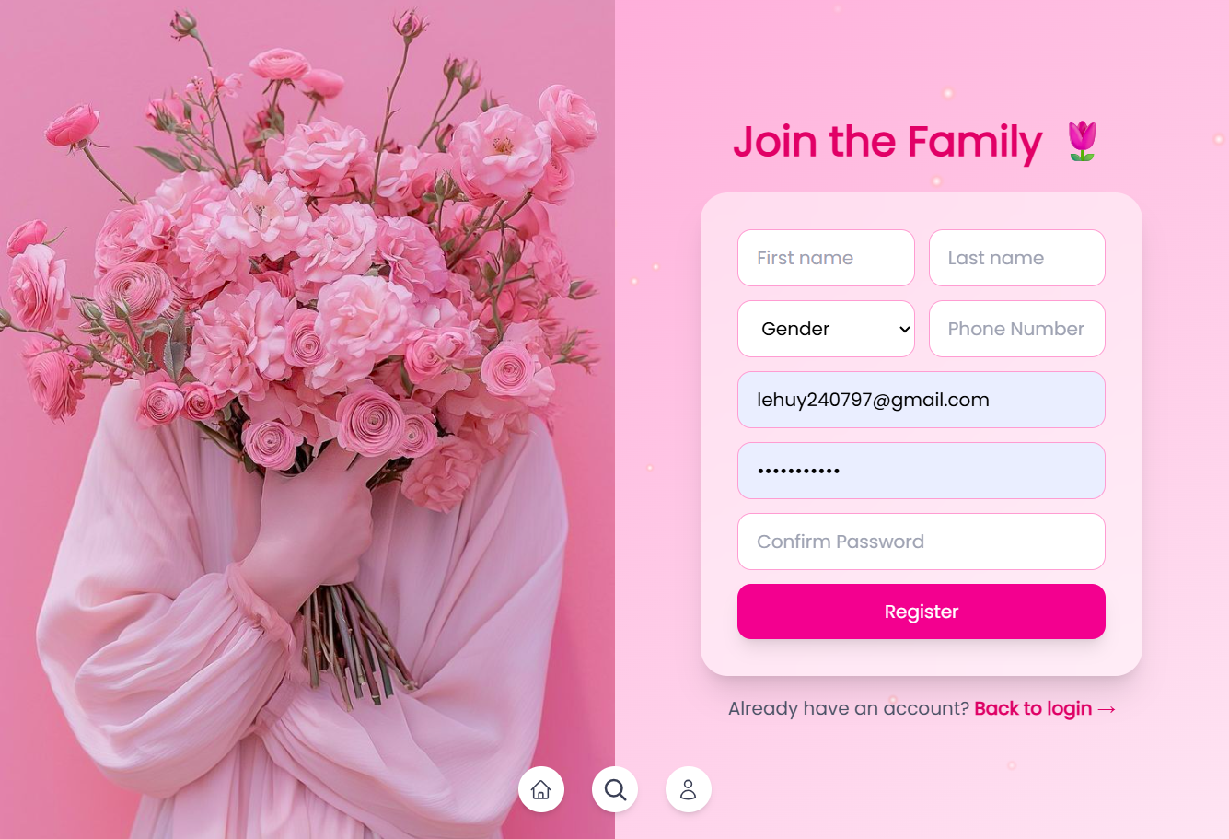

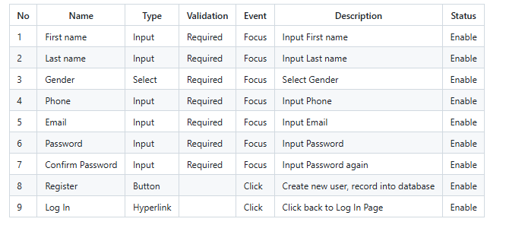

#### 1.4 Login Page

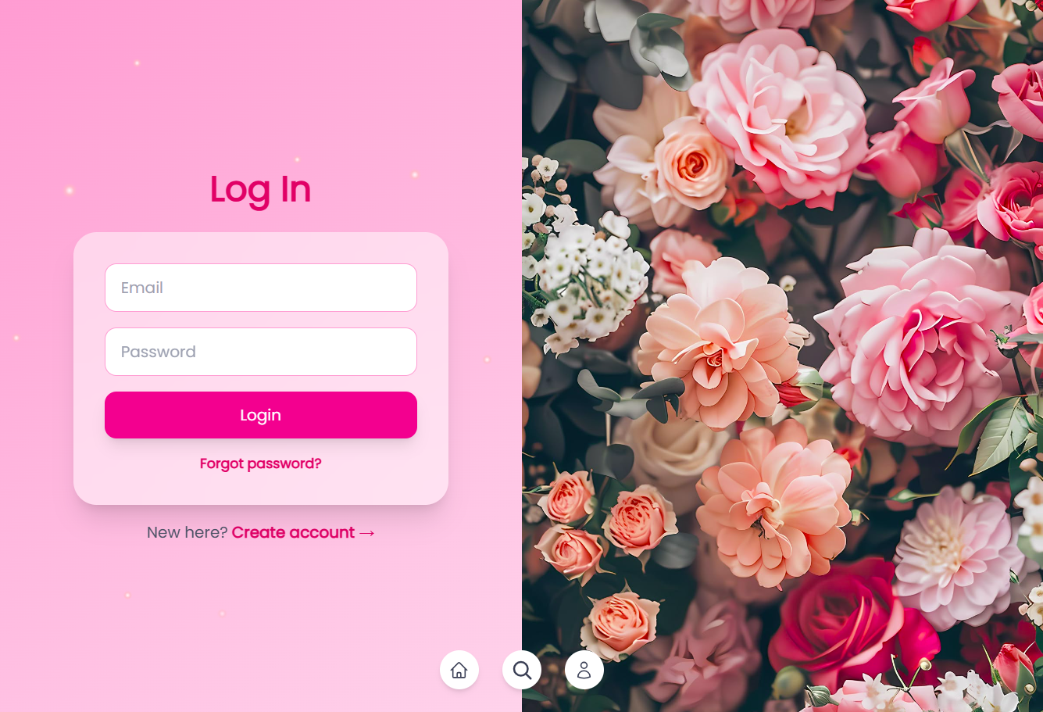

#### 1.5 All-

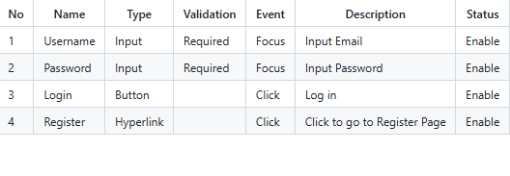

#### 1.5 Bouquets Page

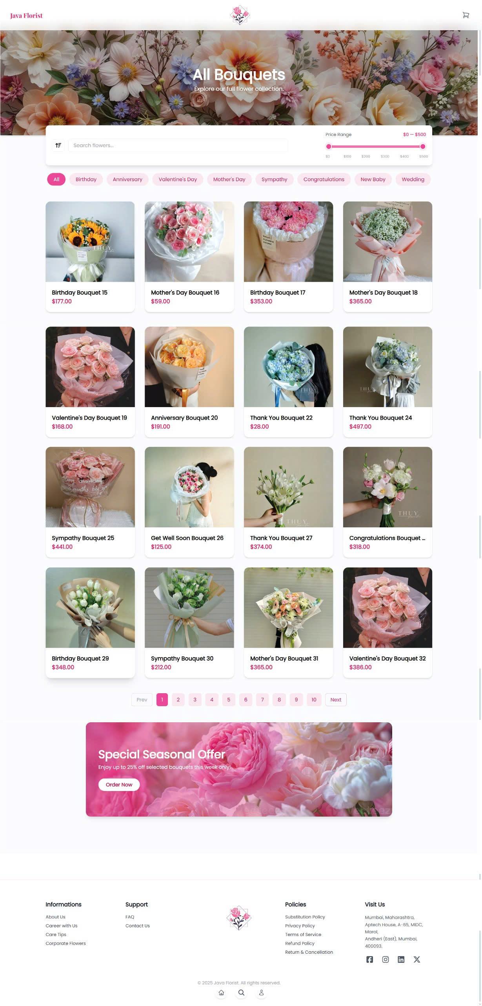

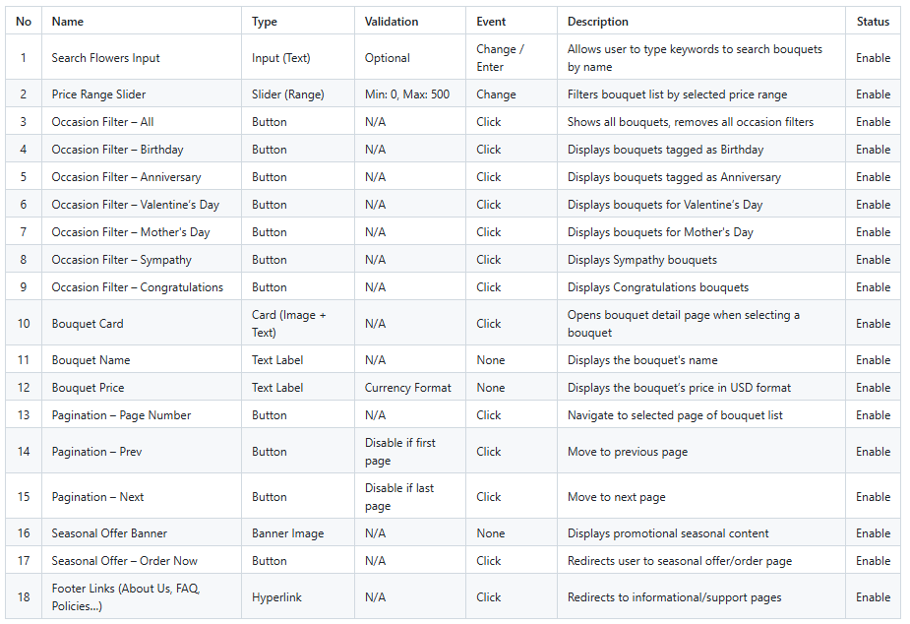

#### 

#### 1.6 Order Page

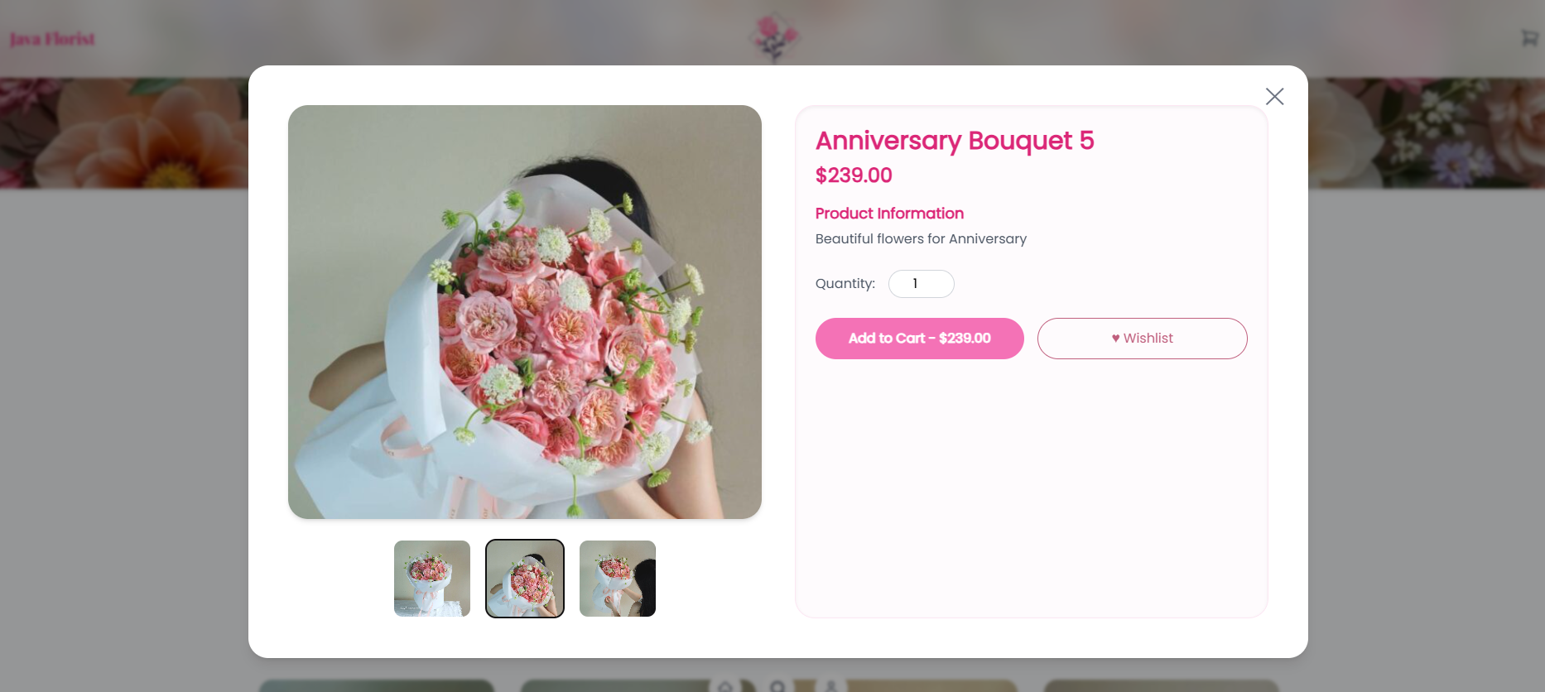

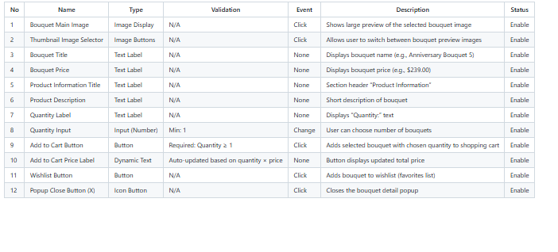

#### 1.7 Check Out Page

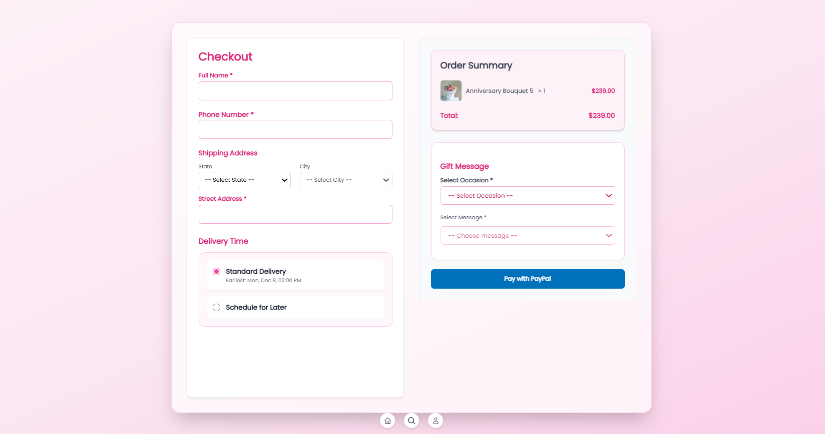

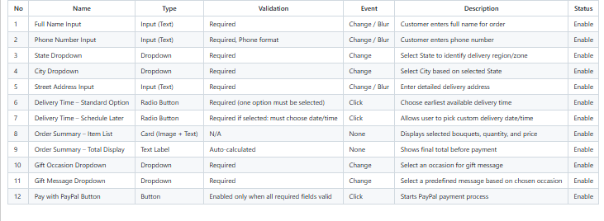

#### 1.8 PayPal page

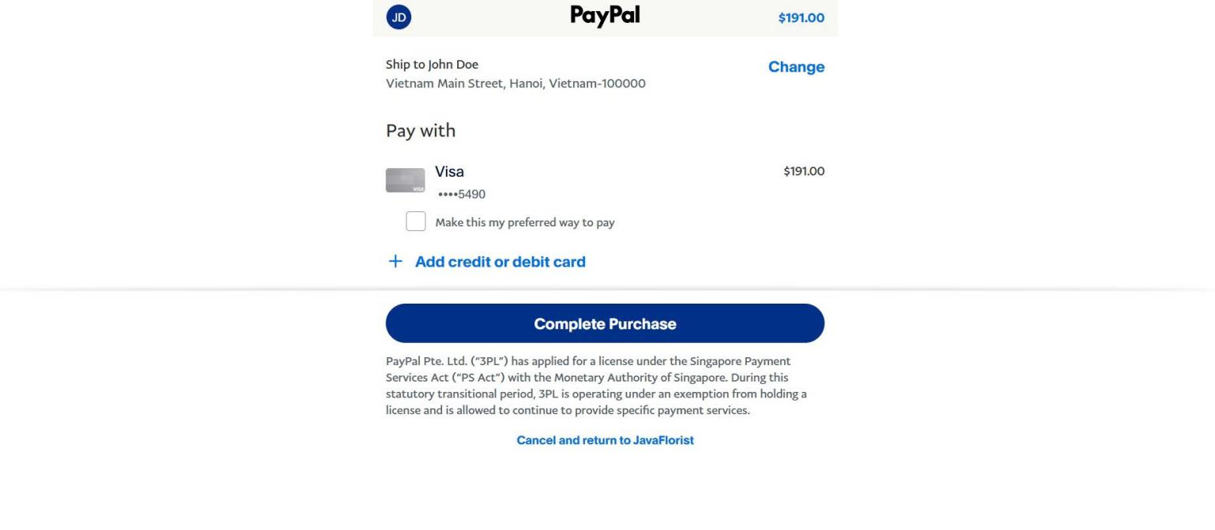

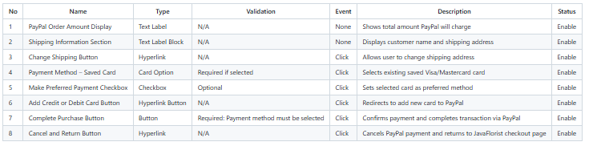

#### 1.9 Use Dashboard

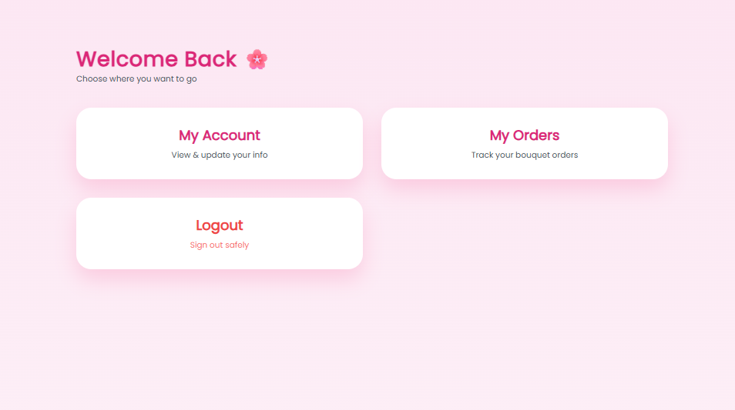

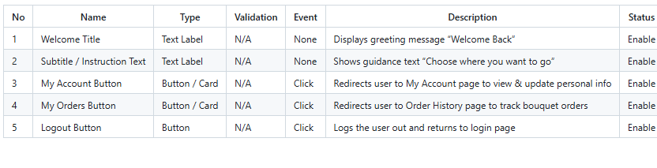

#### 1.10 Your Profile

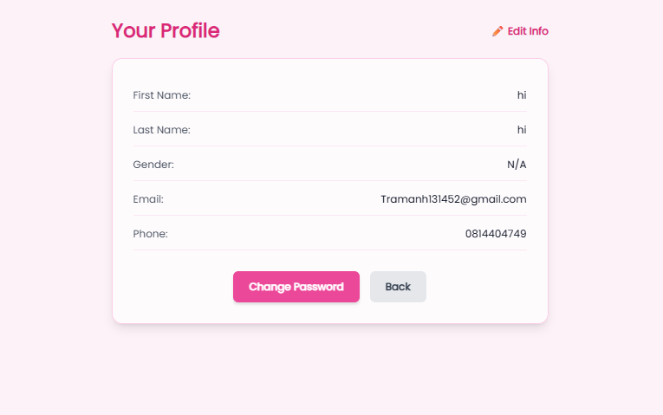

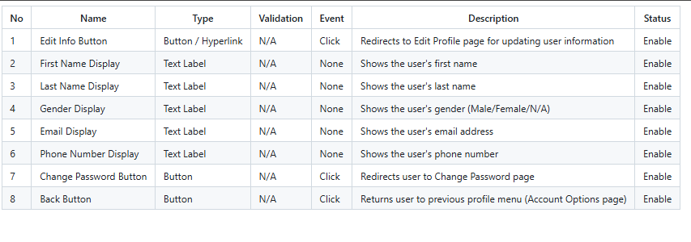

### 1.11 User Order History

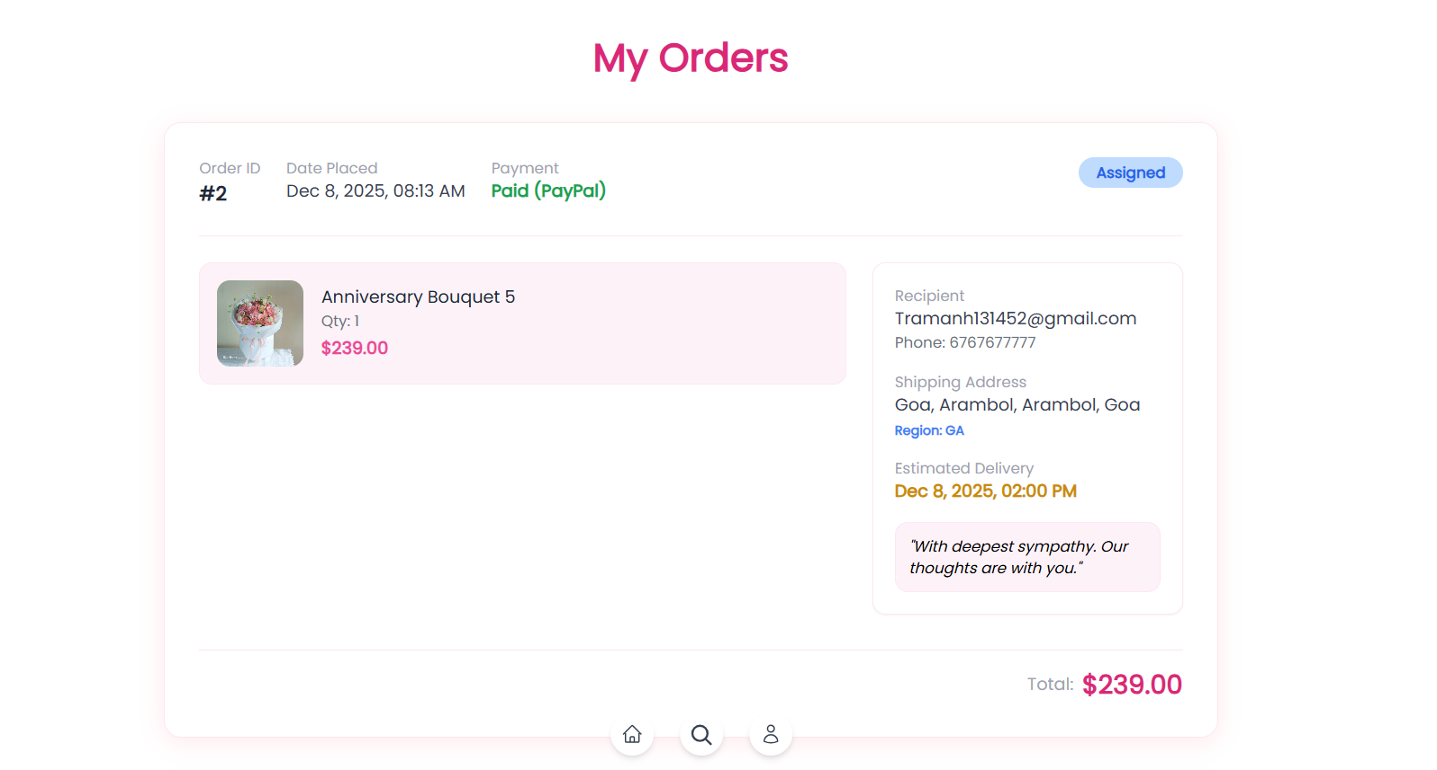

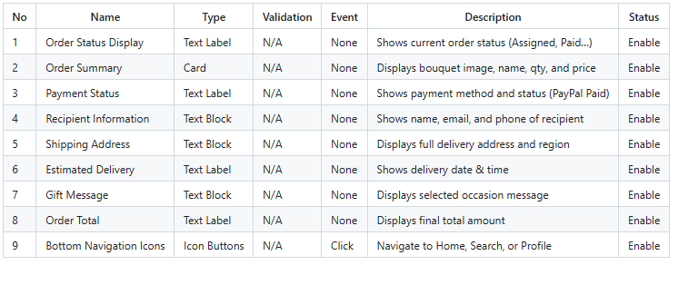

### 2.Partner

#### 2.1 Partner Registration

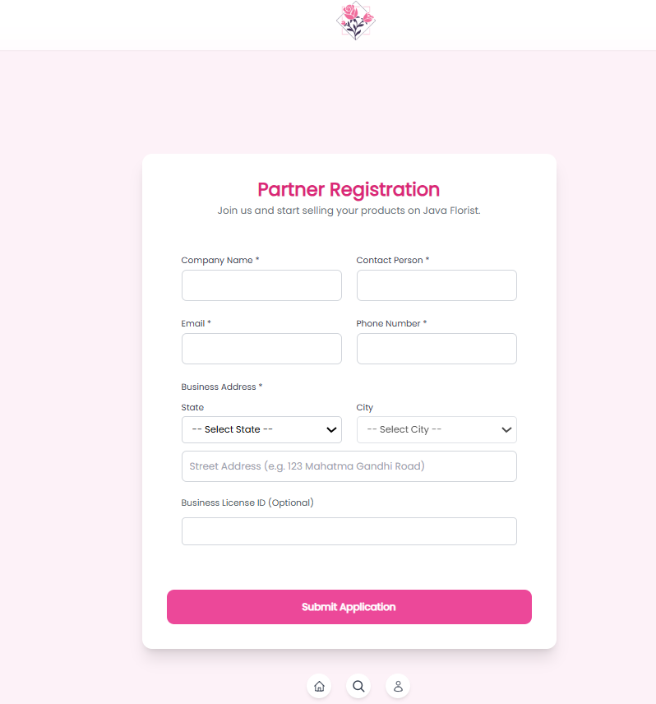

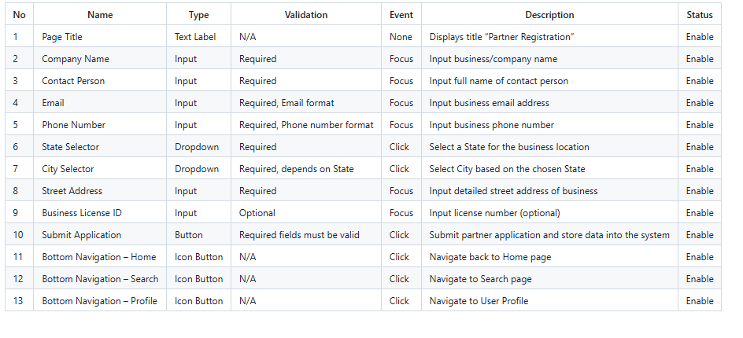

#### 2.2 Partner Dashboard

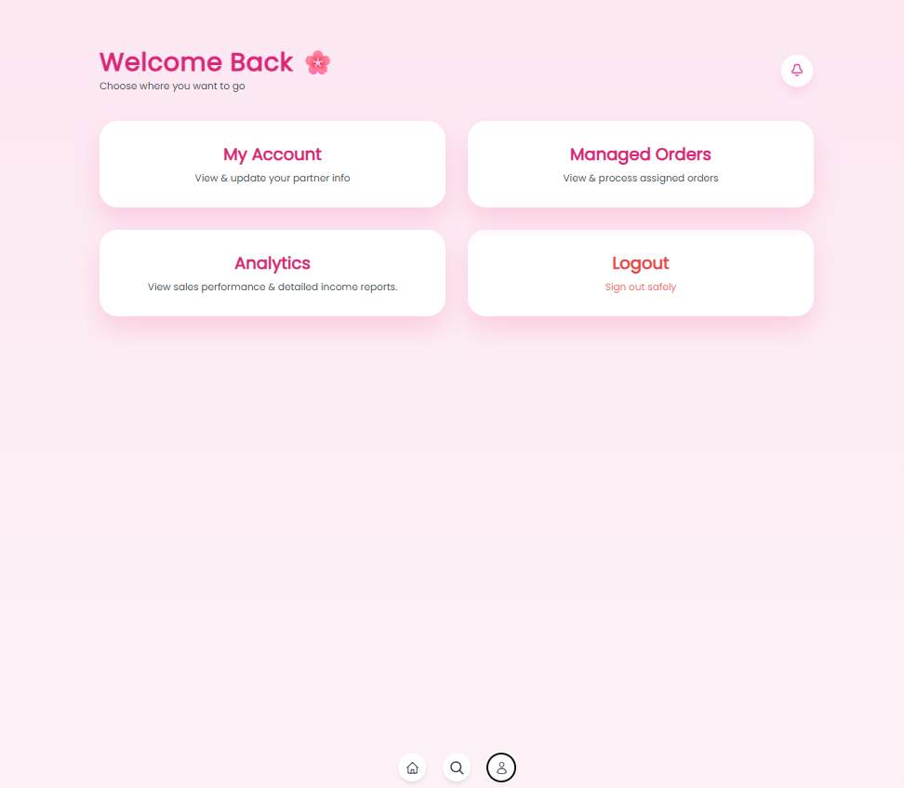

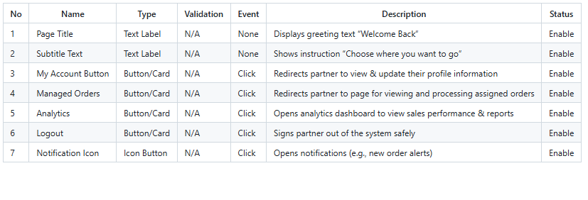

#### 2.3 Acount manager

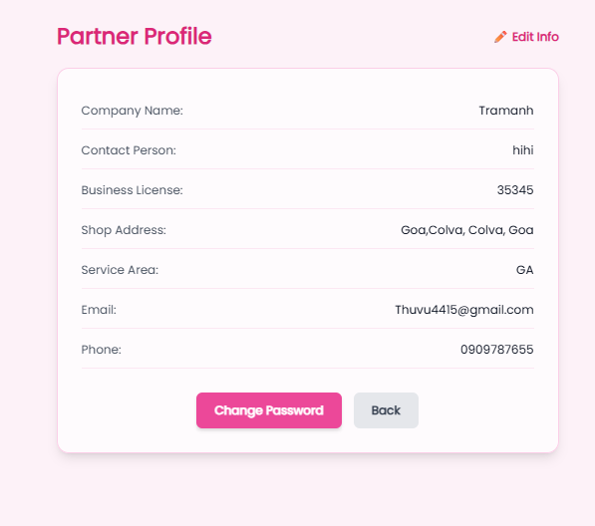

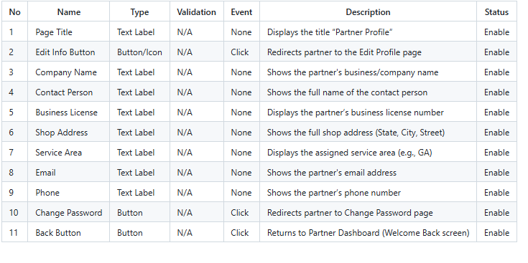

#### 2.4 Order Managemnt

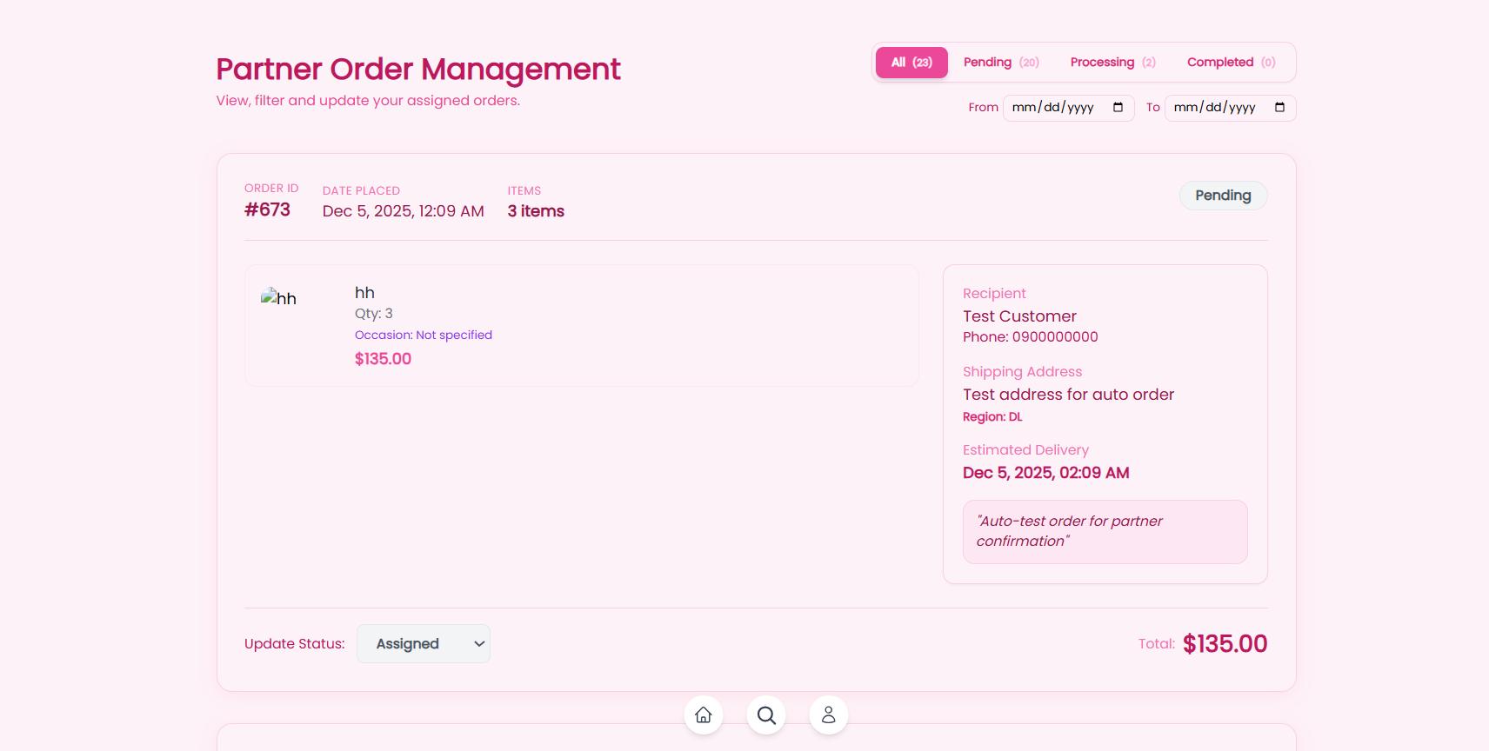

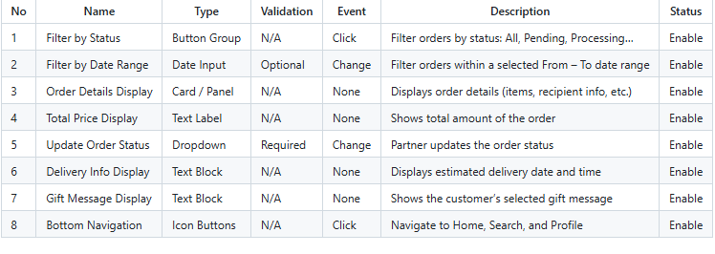

### Admin

#### 3.1 Login Admin

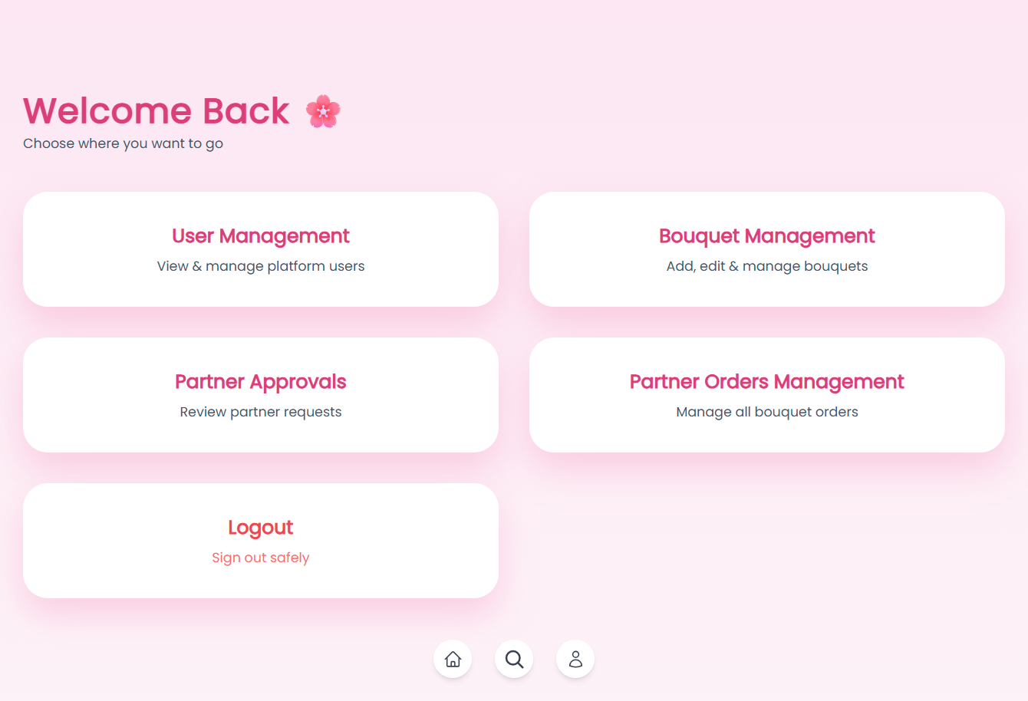

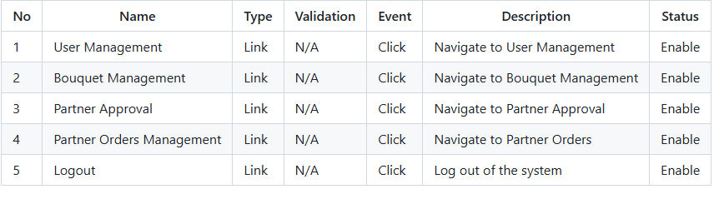

#### 3.2 User Management

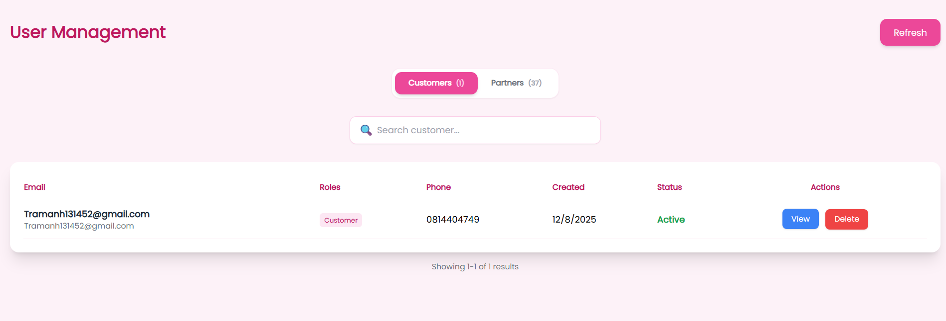

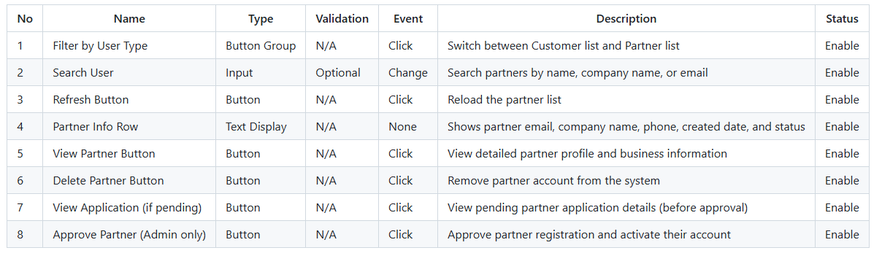

#### 3.3 User Management (Detail Page)

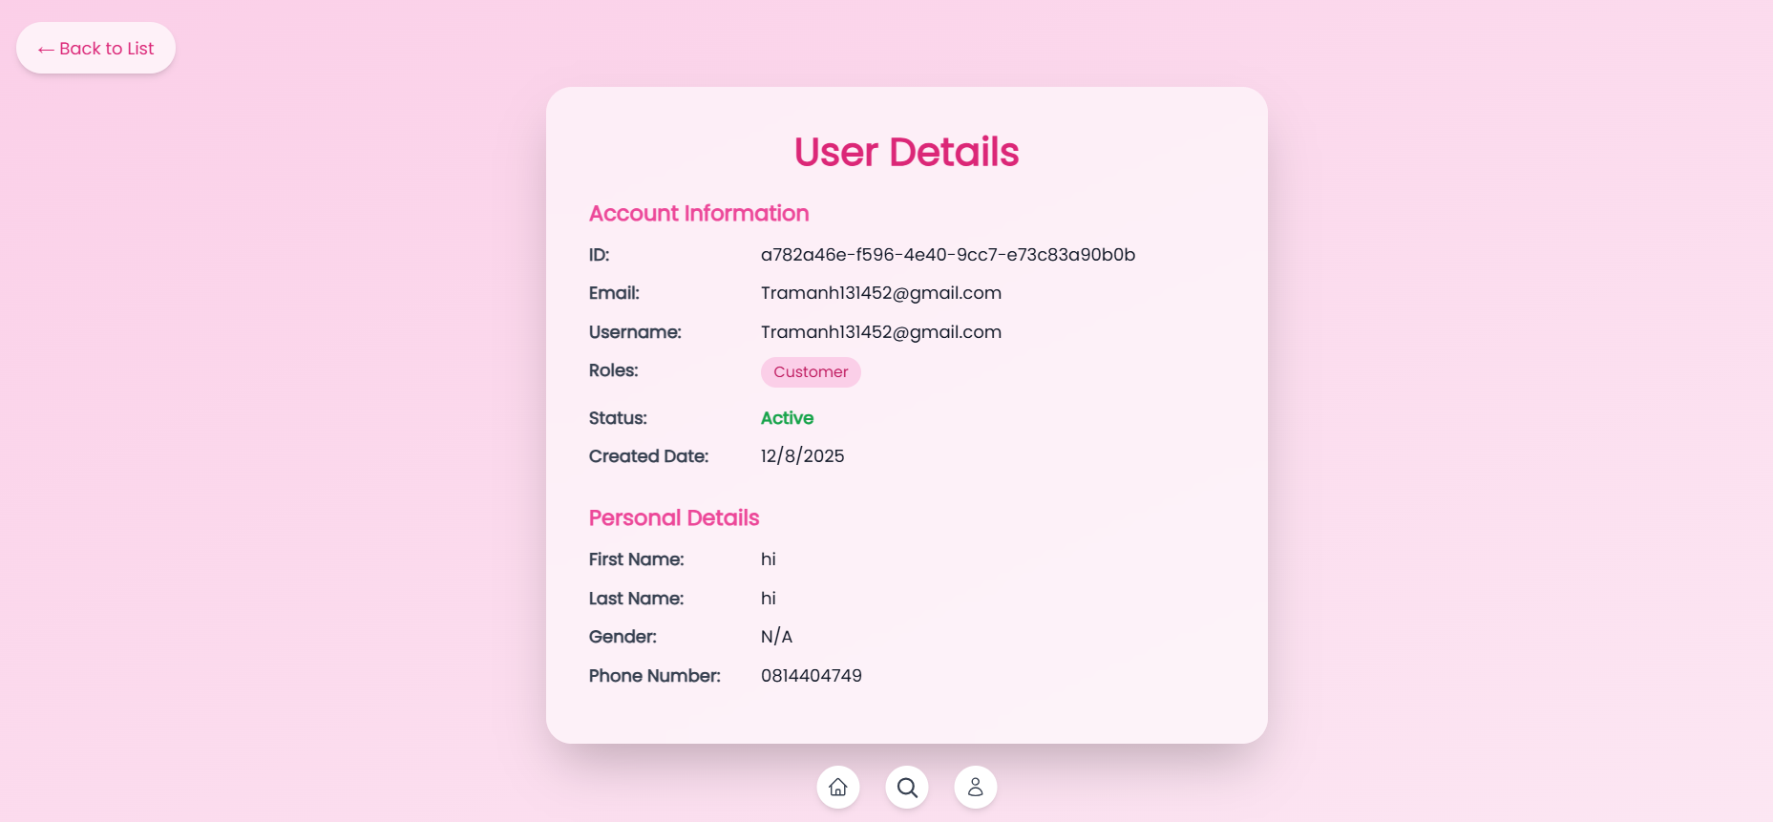

#### 3.4 Bouquet Management

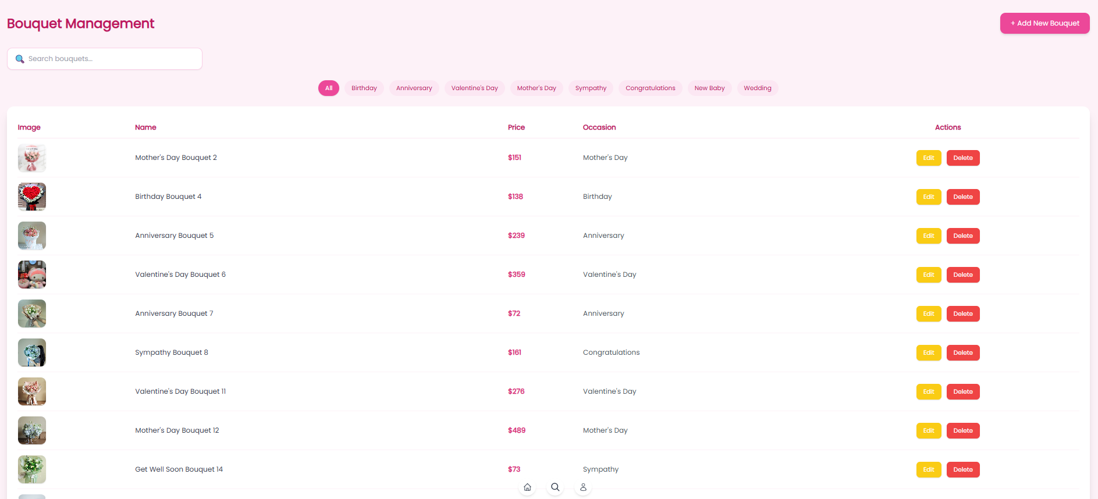

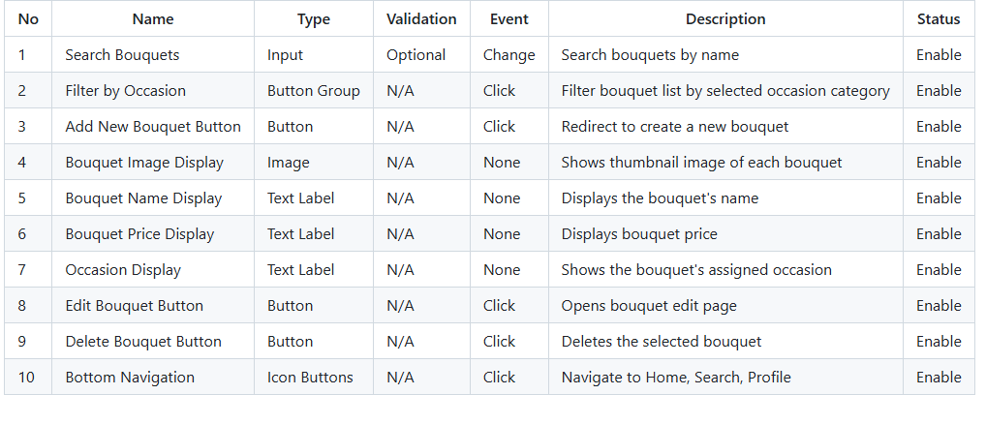

#### 3.5 Bouquet Management(Edit page)

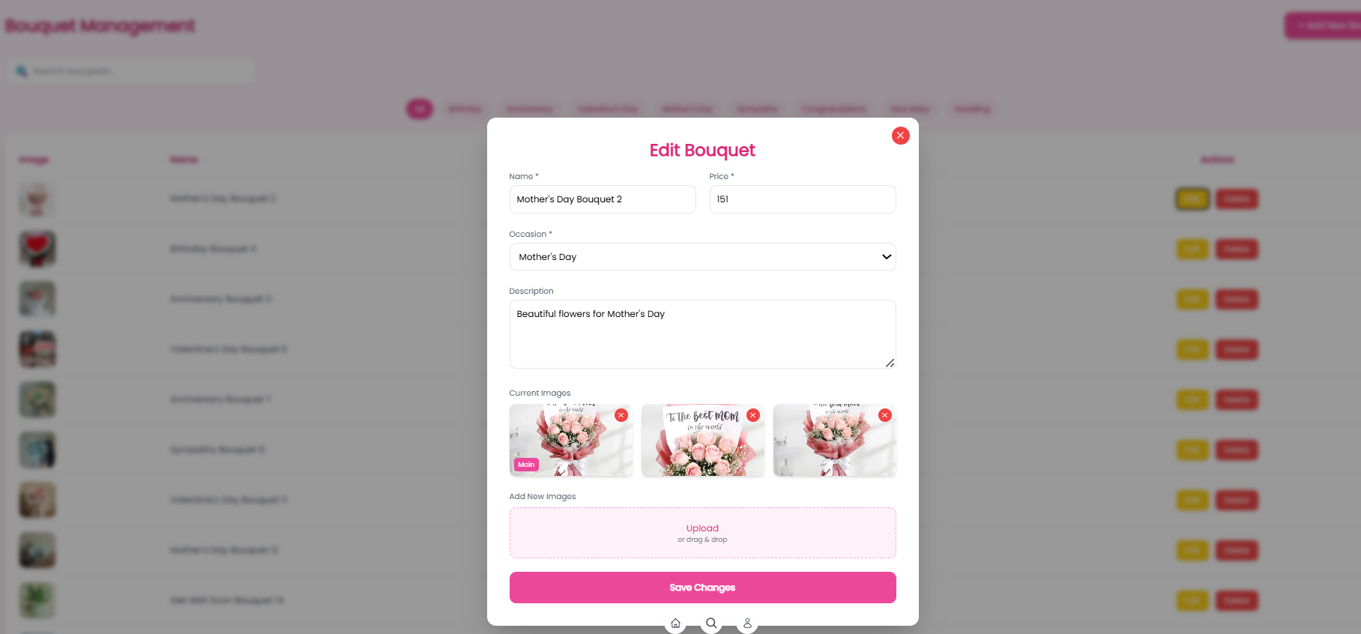

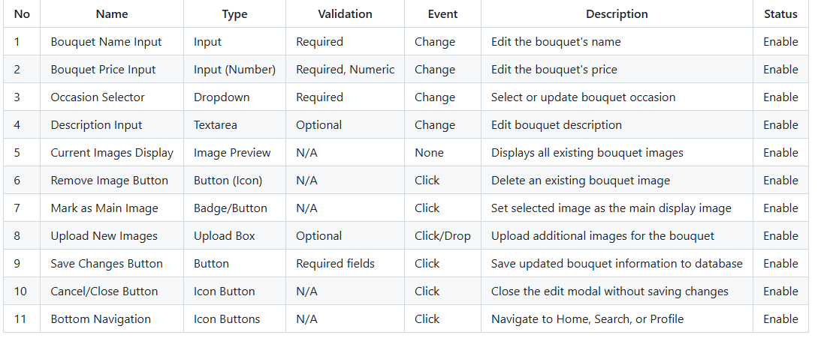

#### 3.6 Bouquet Management(Add page)

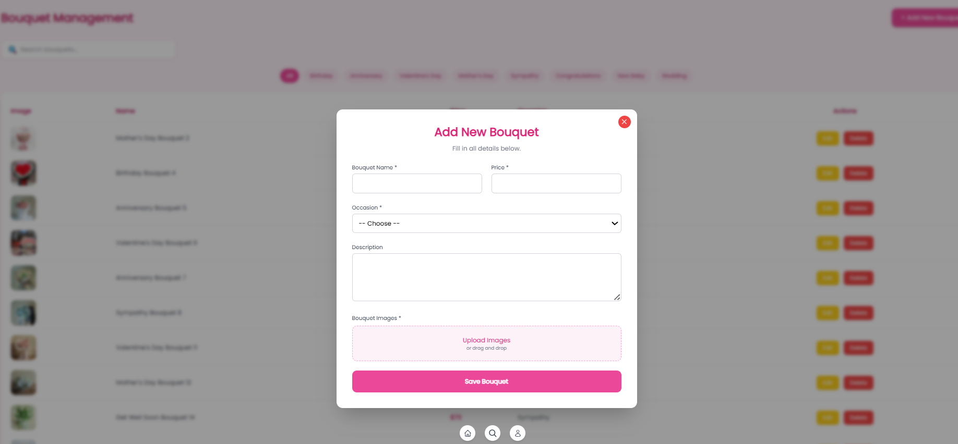

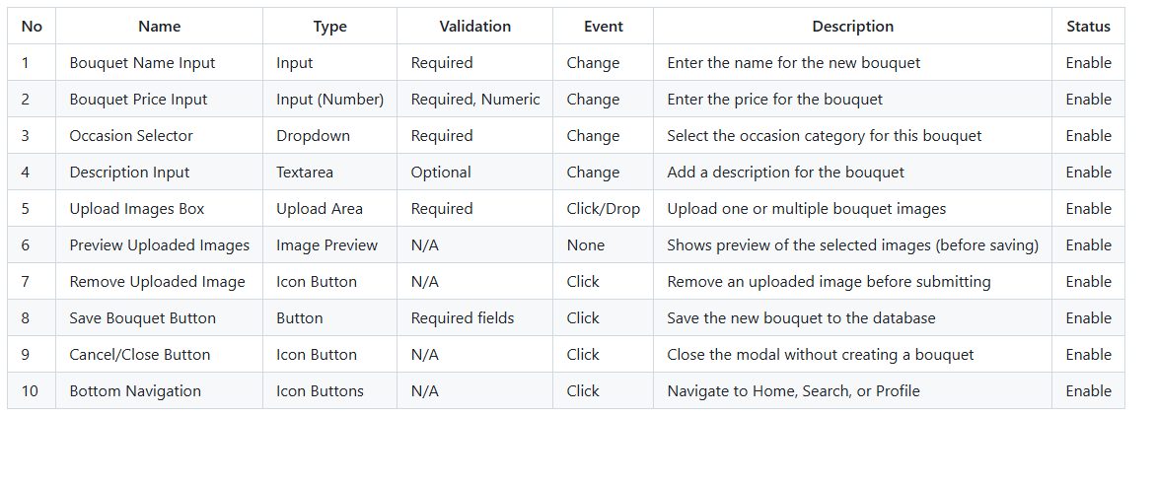

#### 3.7 Pending Partner Applications

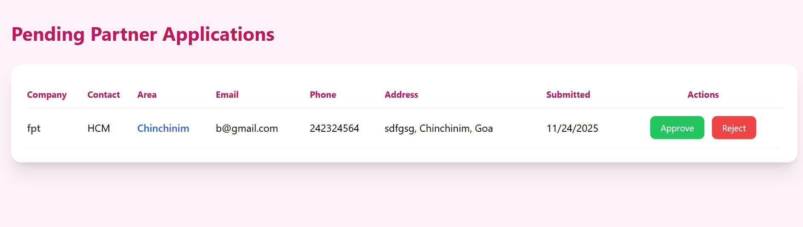

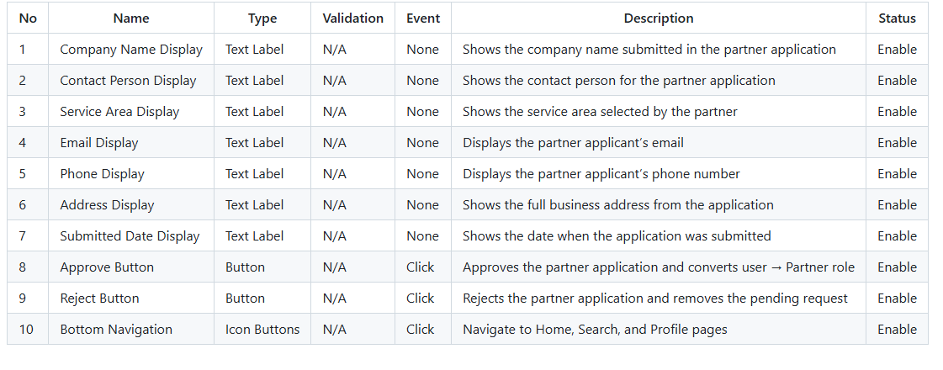

#### 3.8 Order Management

